Simple active learning activities that can be used throughout EACH and EVERY curriculum area!
Birkby Infant and Nursery School Active learning
Rock Paper scissors  No resources needed!  Show children a question with three possible answers. Each answer shows a different action.  Children to stand up and face their partner, complete a rock, paper, scissors and show the action that matches the answer. Use sentence stems to explain answers. Can be used throughout any curriculum area, great for reviewing previous learning and equally good for assessment at the end of a session. | 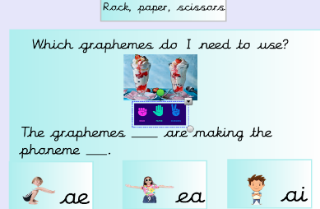  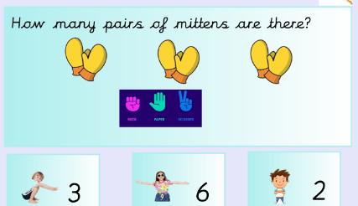  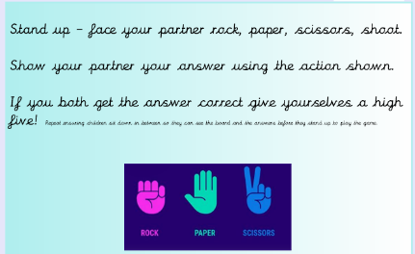  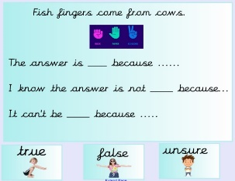  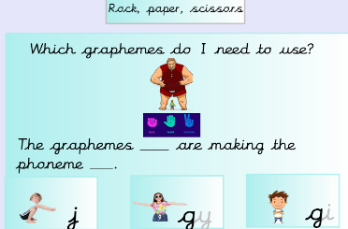
Hot potato  Again no resources needed for this! Ideal for review, plenary and also within the lesson. On the board have questions, graphemes, calculations hidden behind shapes. Behind some of the shapes have a hot potato (can be anything, can link nicely to topic) If we reveal a hot potato children have to stand up and perform a hot potato dance. (Allow children 5/10 seconds to do this) 5,4,3,2,1 voices gone, children sit down at this point.  Could do robots – show me a robot dance ect. | 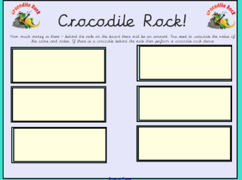  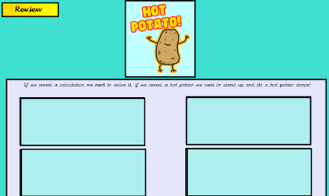  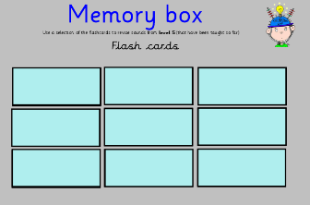  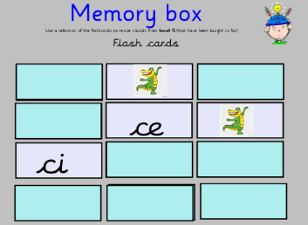  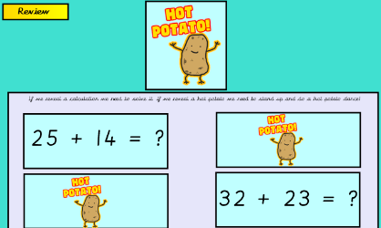
Peg game  On each table have a plate of pegs, enough for one peg for each child. On the carpet place a corresponding plate with the resources the group needs. You then give different words, instructions, clues depending on the activity. Child 1 collects the answer from the plate on the carpet using their peg they pass the answer around the group using only the pegs. Next round player 2 collects the answer and so on. | 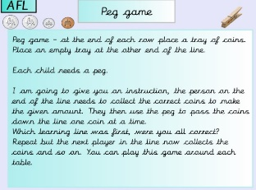  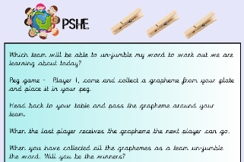  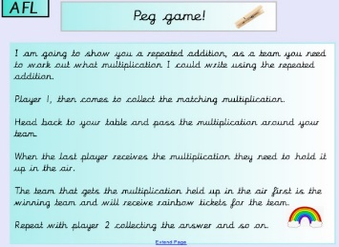  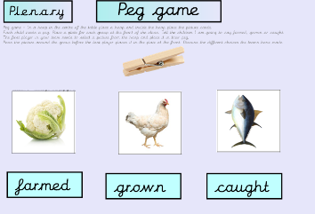  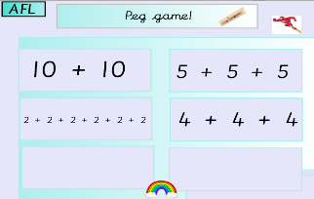
Tick Cross/True false  Birkby Infant and Nursery School Active learning  Children record the numbers 1-6 on their board (can do less e.g 1-4)  Around the room place numbered questions, these could be a statement to match a picture, a question, a calculation with an answer ect. Children have to decide if the statement is true or false and on their board mark the number accordingly. Make numbers 5+6 challenge questions where you stretch thinking further.  Share answers when returning to the carpet to assess understanding. | 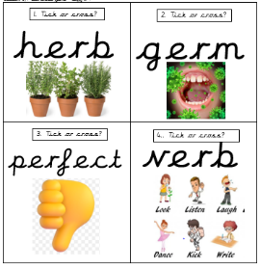  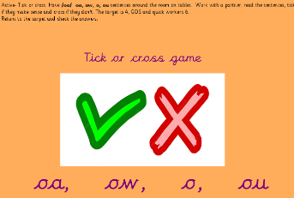  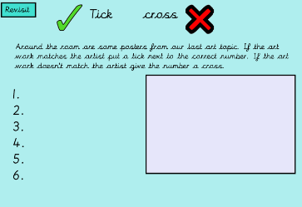  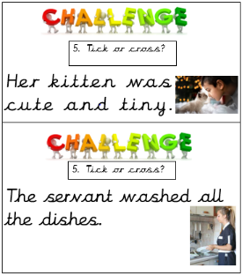  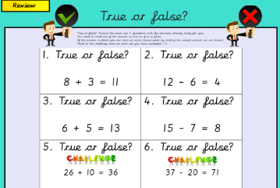  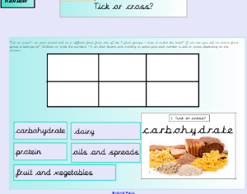
Roll and Read  Place the roll and read cards around the room. Again these can be for any subject. On the numbered pictures place a calculation, a picture, a set of graphemes ect. Children then roll their own dice and head to the card that matches the dice number they rolled. Children then record their answer on their roll and read board. Can work for absolutely any subject and great activity for any part of the lesson. | 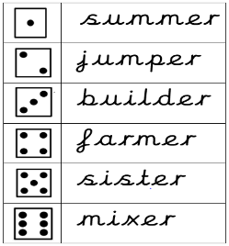  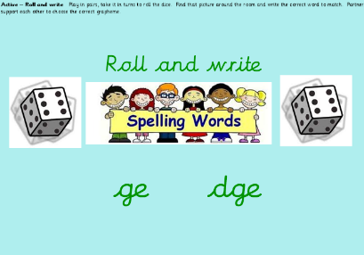  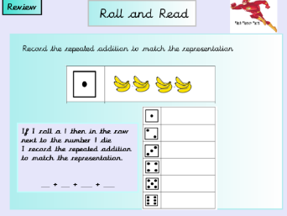  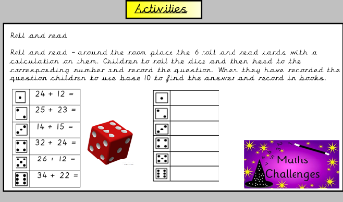
Spin the wheel  Incredibly simple but super effective this is an absolute hit with my class. Create your own spinning wheel on https://wheelofnames.com/  You can make these for any subject, excellent review or plenary tool. Customise it with your own questions then add in a picture (topic related) if the wheel lands on a question the children need to answer it – if it lands on the picture they need to dance!  You can share these wheels by coping the link and then linking in your smartboard. Honestly an absolute hit and super simple. | 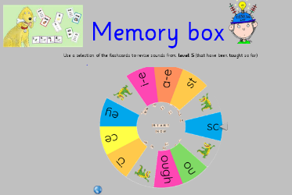  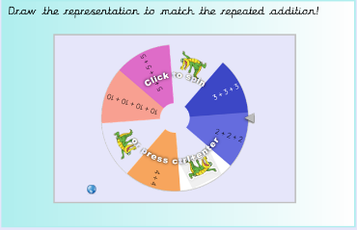  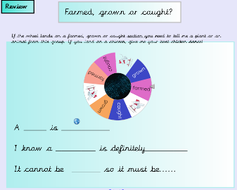  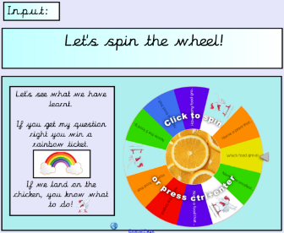
Boom, clap, snap  Birkby Infant and Nursery School Active learning  Children to sit facing each other, stand facing each other at the table - you can choose different ways! If I say clap, clap your hands, if I say boom, tap your knees, if I say snatch you need to be the first player to select the answer. If you snatch the answer before I say snatch then you loose a point. Say different clap and boom rhythms before saying snatch. Display the question on the board so children know what answer they are looking for but they can’t get it until you have said snatch! Helps build patience! | 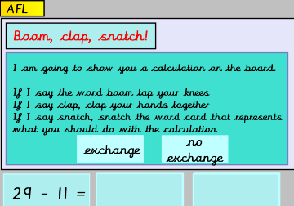  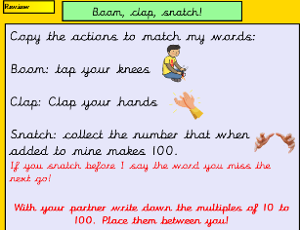  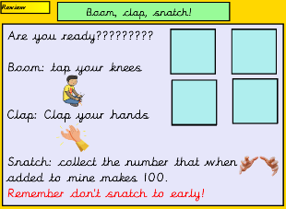
Yoga poses  Incredibly simple, not a single resource needed, fabulous assessment tool. Reduce copying of answers by asking children to close their eyes before they show you the pose. Can be used in each and every subject. Pose a statement, ask a question, children then show the yoga pose to match the answer they think is correct. | 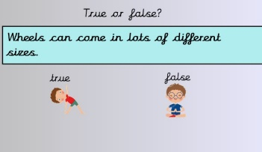  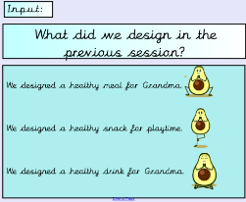  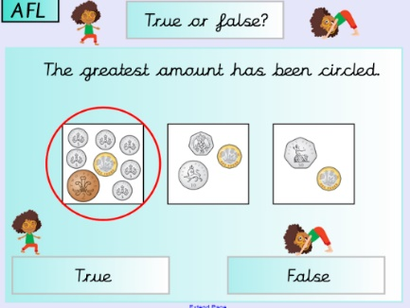  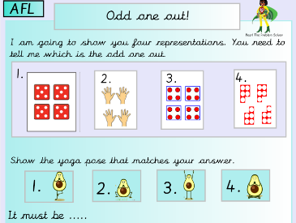  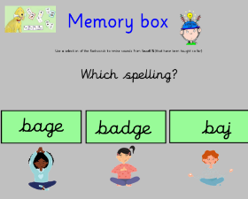
Stand up pair share  Instant active and incredibly effective for developing good communication skills. When posing statements and asking questions ask children to stand up and pair share their ideas. Establish good routines early on, face your partner, take turns to speak, use full sentences, use sentence stems to support this 5, 4, 3, 2, 1 voices gone, all children sit down and ask children to share their thinking.  Try it! | 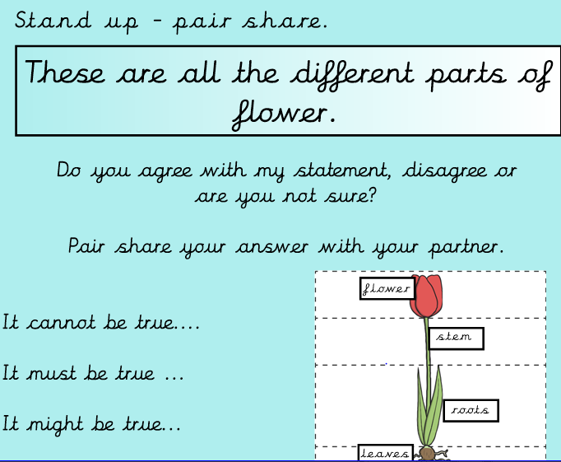  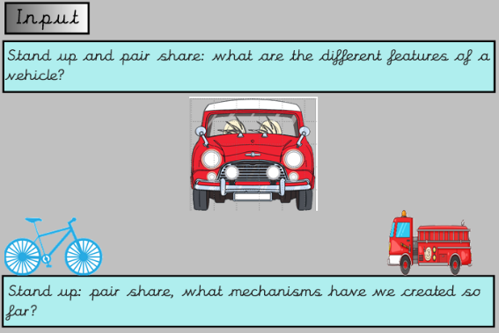
Hands behind your back  Birkby Infant and Nursery School Active learning  Great activity for showing answers again provides instant assessment and ensures children are thinking for themselves. Great for number bonds or to give the answer to multiple choice question.  E.g I have 5 hands behind your back, 3, 2, 1, show me how many more to make 10. (children can show you different ways to make the 5 you need, 4+1, 3+2, 5)  Multiple choice, hands behind your back 3, 2, 1 show me the answer. | 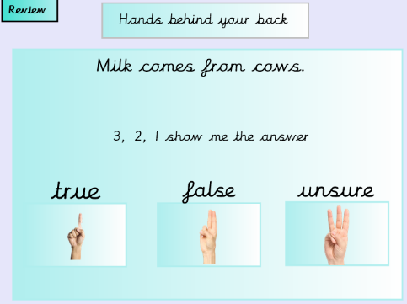  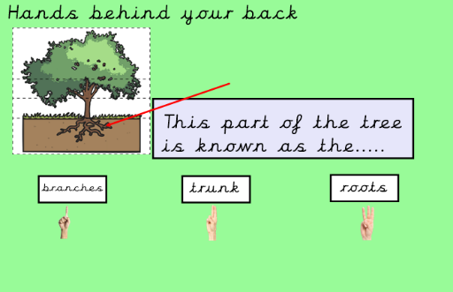  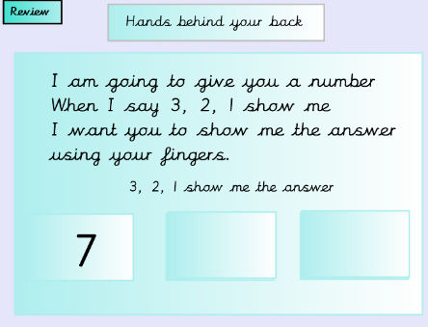
Missing answer  You can also use the wheel of names for this activity. In hoops around the room place the answers to the questions you are going to ask – more hoops are better to reduce crowding. Don’t have enough answers for every pair, increases speed and competition. Pose the question – give children 3 seconds to discuss with partner. Partner 1 goes to collect the answer. Partner 2 checks they are correct. Repeat with a new question and partner 2 collecting the answer. | 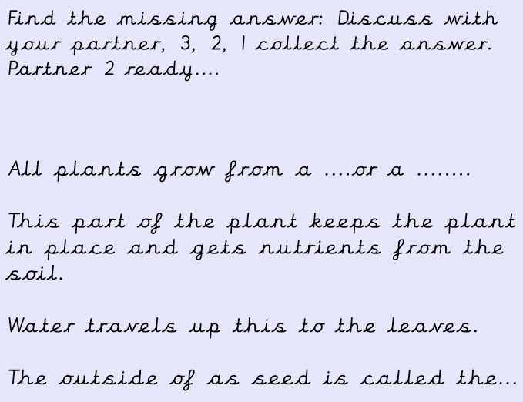  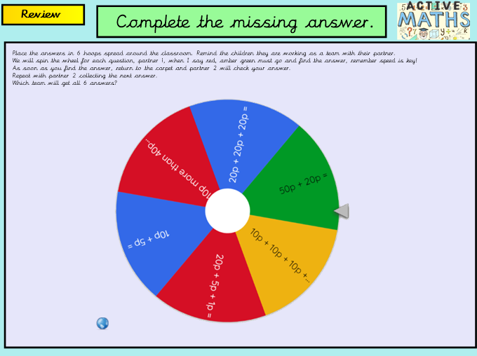
Speed Bounce  Working in pairs (Means you need less room) Can be used to reinforce number bonds, multiples of number, counting, phonemes, graphemes, spellings, words all sorts. Set up speed bounce stations and depending on the area you are focusing on children working in pairs to complete the challenge. Eg spell cat partner 1 jumps over the cones and says -c-a-t partner 2 records the graphemes partner 1 said and then checks if they were right. Swap roles. | 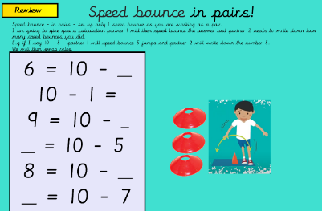  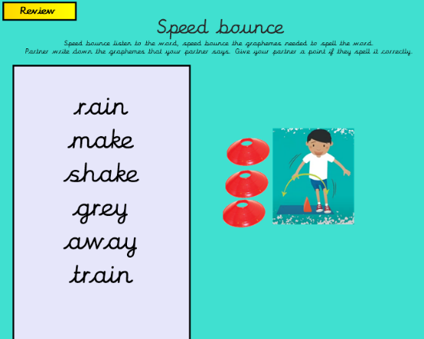
Gallery walks  Can be used in each and every lesson. Display work around the room that encourages children to move. It may be look at the different paintings by the artists, which artist do you think created these paintings? Maths activities, are the groups equal or unequal, around the room are the numbers 1-6 are the groups by the numbers equal or unequal, record your ideas. Can be used in many different ways, use the walls, doors, chairs, tables to post activities. Make sure you have duplicate sets to reduce crowding. | 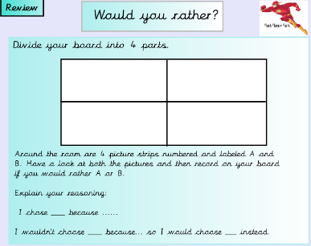  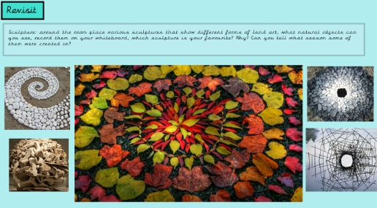  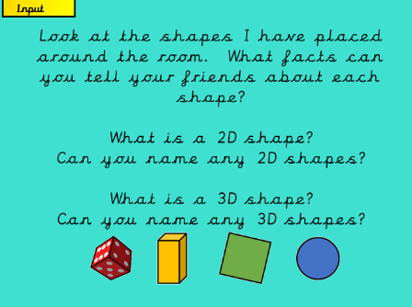  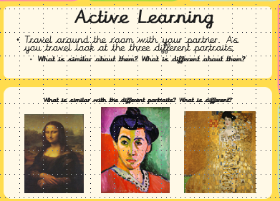  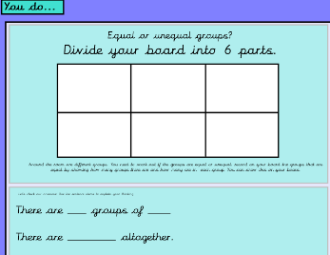
Punctuation Police  Again can be used across multiple topics. Make obvious mistakes and the children need to solve the crimes as they move around the room. You could be conjunction constables, adjectives detectives, letter detectives, number explorers…the list is endless. Children solve the different crimes, recording their answers on the move. | 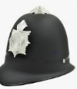  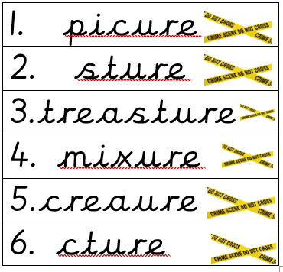  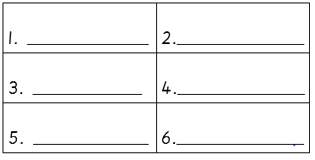
Treasure hunt  Time to get moving by solving the clues. Children need to solve the question to find the answer. Head to the answers around the room and find the one that matches. On the answer will be a letter. Children then need to unjumble the letters to solve the missing word. Link this to the topic you are learning. Works equally well with common exception words, phonemes that you are learning, words containing the phonemes ect. | 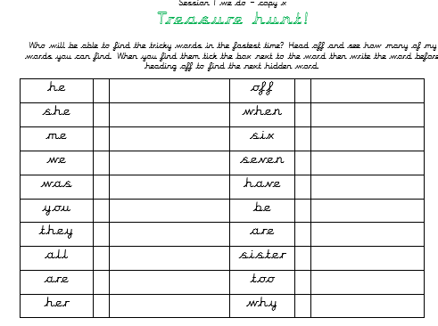  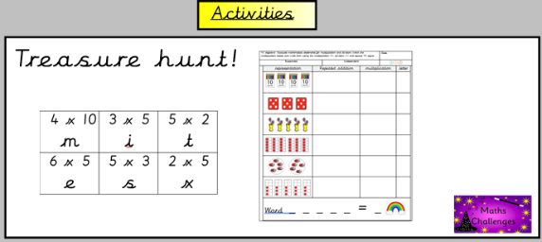
Birkby Infant and Nursery School Active learning

